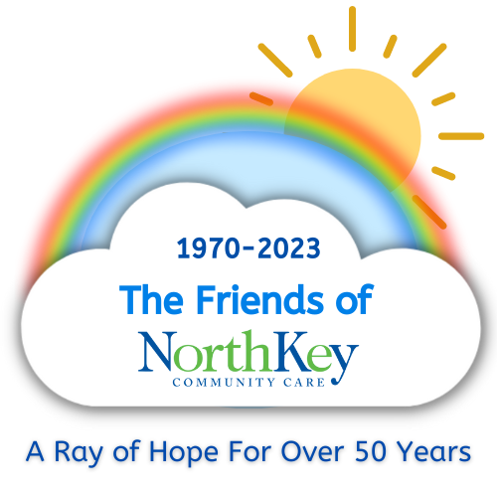

The Friends of NorthKey

January 2023

Dear Friend:

We hope that you and your family are staying healthy. Thanks to your past support, The Friends of NorthKey Community Care has been able to continue its mission to raise awareness of mental health issues and reduce the stigma surrounding mental illness.

We hope you will continue to support our activities and efforts through continuation of your annual dues. If you have family or friends that would be interested in becoming a member of the Friends of NorthKey, please pass along a copy of this letter to them or provide them with the contact information below. If you would like to attend our monthly meetings, please contact Laura Harris at 859-578-3200 x3201 or email at lharris@northkey.org

Additionally, we invite you to attend our Fundraising Event that we are planning in the Fall of 2023. More information will be distributed about the Fall Event at a later date.

Yearly Dues remain $10.00 per person.

Thank you for your support!

____________________ ___________________________
Deana Combs, Chair Anne Scheve, Membership Chair

Please return the bottom portion of this letter with your check payable to The Friends of NorthKey Community Care, and mail to Anne Scheve at P.O. Box 2680, Covington, KY 41012

Name:__________________________________________________________________

Address:________________________________________________________________

Active Member:________________ Supporting Member:_____________

Contributor:___________________ Email Address___________________________

